Project: Marketing Campaign Effectiveness Analysis (Hypothetical Data)
Objective: Identify which marketing campaigns and channels drive higher conversions and revenue and recommend actions to improve performance.
Approach
- Loaded marketing data into Power BI and created visuals for:
  - Daily revenue trend
  - Daily conversion rate trend
  - Return on Ad Spend(ROAS)by channel
  - Top campaigns by revenue
- Built KPI measures (Revenue, Spend, ROAS, Conversion Rate(CVR), Cost Per Acquisition(CPA)) for consistent performance evaluation.
- Reviewed A/B test results using CVR and revenue-per-visitor to support decision-making.
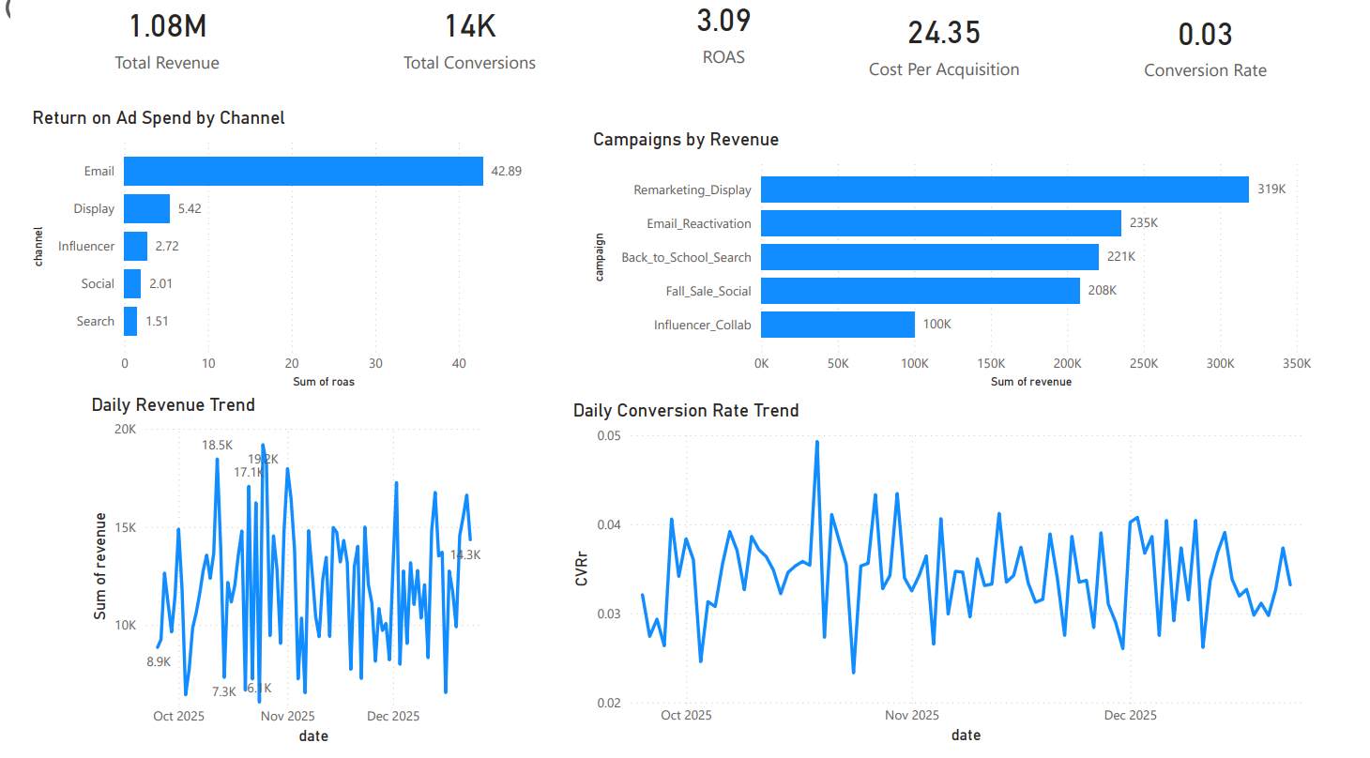
Key Insights
- Email channel produced the highest ROAS, indicating strong efficiency and profitability potential.
- Remarketing/Display generated the highest campaign revenue and is a strong scaling channel.
- Conversion rate stayed relatively stable with normal daily fluctuations.
Recommendations
- Allocate more budget toward the highest ROAS channels while monitoring saturation.
- Optimize low-ROAS channels through targeting refinement, landing page improvements, and creative testing.
- Continue A/B testing with revenue-per-visitor (not Conversion Rate alone) as a primary decision metric.

